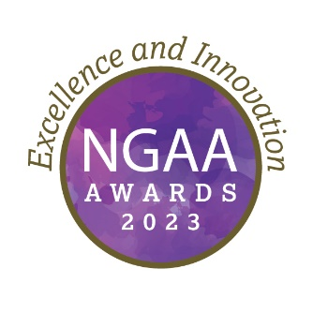
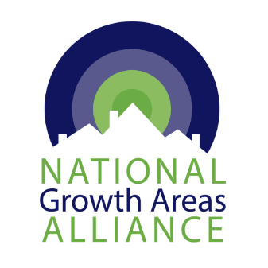
2023 NGAA Awards
Submission Form

Submissions are invited for the 2023 NGAA Awards, celebrating and showcasing excellence and best practice from projects and initiatives supporting the development of growth areas across the country.
Submissions will be assessed by a panel of industry experts and winners will be announced at the NGAA Congress Dinner on Thursday, 4 May during the NGAA’s 2023 Annual Congress.
Member Councils and industry bodies can enter projects and initiatives in one or more categories. Submissions must be supported by:
- Responses to five questions
- Project Summary (250 words)
- Issue identification (100 words)
- Importance of project to growth areas (300 words)
- Methodology (300 words)
- Goals and outcomes (300 words)
- 1 – 5 images, and/ or
- Video footage up to 2 minutes (optional)
Please complete this form, save with your Council name-NGAA Awards in the title and email with photo or video attachments to Bronwen.clark@ngaa.org.au by Monday 17 April 2023.

2023 Award Categories
1. Research and Practice
Local Government-led research or innovative practice that has led to improved outcomes for growth areas (Individual LGA or collaboration with industry/academia).
2. Built Environment
Completed projects in the built environment that show best practice design, collaboration and impact.
3. Partnerships - Building Connections
Partnerships that have achieved better outcomes for communities – Industry, Local, State or Federal Government, Community, other Stakeholders

4. Advocacy
Outcomes in funding or policy that were achieved through dedicated advocacy efforts (to any level of government).
5. Leadership in Growth Areas
Recognition of an individual or team who has shown an outstanding commitment and leadership to pursuing better outcomes for growth areas, in any aspect of Council work. This award is offered in ongoing recognition of the leadership of the founders of NGAA.

Award Criteria
See https://ngaa.org.au/awards for detailed assessment criteria for each category.

Eligibility
To be eligible for consideration in the 2023 NGAA Awards, submissions must:
- Reflect a project or action located in an outer urban growth area of a capital city;
- Be submitted by, or include, at least one NGAA Member Council;
- Meet the Award criteria and addresses the appropriate Award category.

Award Submission Form
- Organisation name
Click or tap here to enter text.

- Name of person making submission
Click or tap here to enter text.

- Email address
Click or tap here to enter text.

- Phone
Click or tap here to enter text.

- Which award category are you applying for? (select one)
☐ Category 1: Research and Practice
☐ Category 2: Built Environment
☐ Category 3: Partnership and Building Connections
☐ Category 4: Advocacy
☐ Category 5: Leadership in Growth Areas

- Project name
Click or tap here to enter text.

- Summary of your project (250 words max)
Click or tap here to enter text.

- How did you identify the issue that needed to be addressed? (100 words max)
Click or tap here to enter text.

- Why is the issue important and relevant to outer urban growth areas (300 words max)
Click or tap here to enter text.

- What was the method/approach you used in this project? (300 words max)
Click or tap here to enter text.

- What were the project’s stated goals and how did you measure the outcomes against them? (300 words max)
Click or tap here to enter text.

- Please include some images and/or video representing the project with your entry.
☐ Images attached to submission email

- If successful, I give permission for NGAA to use and/or reproduce all written content and imagery submitted for promotional purposes.
☐ YES
☐ NO

- This submission has the support of relevant Council Director/CEO.
☐ YES
☐ NO

PLEASE EMAIL COMPLETED FORM WITH IMAGES TO BRONWEN.CLARK@NGAA.ORG.AU

